**Design and Implementation of a Full Model Hindlimb Model of a Rat**

**Fletcher Young**

# Abstract

The purpose of this work is to develop a hindlimb muscle model to better understand the hierarchical control structure of reflex modulation. This model will use information from the literature to estimate parameters for all muscles in the hindlimb. Using optimization techniques and the hindlimb model, known torque profiles will be deconstructed into muscle force profiles.

To better understand how output kinematics are dictated by underlying neural structures, this work will:

**Aim 1 - Expand a neuromechanical model of a rat hindlimb to include a complete musculature with physiological muscle paths.** Muscle paths from the literature will be incorporated into a three-dimensional model of the rat hindlimb. Model kinematics will be compared to hindlimb models in the literature to demonstrate efficacy.

**Aim 2 – Investigate muscle activation strategies that meet torque demands under nominal and perturbed conditions.** Muscle model parameters will be developed from physiological measurements in the literature. Experimental measurements for joint motion and torque measurements will be used to calculate muscle forces. Muscle forces will then be converted to muscle activation profiles that will be organized and compared for different locomotion situations.

**Aim 3 – Create novel simulation tools for neuromechanical simulations focused on large-scale neural network design.** A novel simulation tool will be developed to specifically aid the construction of large-scale neural networks using recently developed design approaches. This work will use open source materials to allow for further development as the field matures. Novel simulation tools will be used to recreate work from past aims and compare output metrics.

Contents

Abstract 0

Background 3

Modeling Considerations 5

Rats as a Model 7

Previous Project Developments 7

Synergies 10

Perturbations 13

Completed Work and Remaining Work 14

Aim 1 - Expand a neuromechanical model of a rat hindlimb to include a complete musculature with physiological muscle paths 14

Completed Work 14

Remaining Work 17

Publications 17

Aim 2 – Investigate muscle activation strategies that meet torque demands under nominal and perturbed conditions 17

Completed Work 17

Remaining Work 27

Publications 27

Aim 3 – Create novel simulation tools for neuromechanical simulations focused on large-scale neural network design 28

Completed Work 28

Remaining Work 30

Publications 30

References 30

# Background

Animals are capable of traversing complex environments by continuously coordinating sensorimotor signals to address navigation demands. A sophisticated control system is necessary to integrate the feedforward decision making processes with the sensory feedback signals that regulate locomotion. The high-dimensional parameterization of sophisticated control systems is difficult to implement in existing robots, leading researchers to develop simplified models that make intelligent robotic navigation tenable. Since animals do not seem to struggle with many of the navigational challenges that robots face, it stands to reason that a control system modeled after biological systems may offer an effective framework for robotic control systems.

Robots and animals must encode environmental state variables in order to regulate downstream reflexes. In vertebrates, these afferent feedback signals are transmitted through the spinal cord to processing centers in the brain, where high level cognitive decisions are made. Efferent signals then transmit higher level instructions to actuators which interface with and, oftentimes, modify the environment. Levels of the nervous system are often distinguished based on the complexity of command signals or the level of cognitive processing associated with the activity. Understanding the functionality of individual levels and the interconnection between them is a constant focus of study.

Typical robotic control systems use a top-down approach, with a high level processing unit directing the integration of sensor input and actuator control. Although the state of the art advances every year, capabilities of advanced robots are still dwarfed by that of newborn animals. While robotic systems are effective at completing predetermined tasks, they lack the generality of task performance. Many newborn animals possess this generality, allowing them to walk just minutes after birth. Robots are better equipped to enter well-understood environments and complete hardcoded tasks rather than modulate their behavior based on varying environmental factors.

Studies have been done on many types of locomotion such as swimming (Weeks and Jr 1978), flying (Chung and Dorothy 2010), or undulating (Bryden and Cohen 2008). Legged locomotion is a preferable approach for navigating complex, human-dominated areas because it offers a stable approach to addressing complex environmental demands. However, the complexity of coordinated legged locomotion necessitates a high level of processing and sophisticated actuators that are simultaneously durable and delicate.

The growing inclusion of biomechanics in robotic design emphasizes the importance of incorporating principles of “living machines” into product development. Walking robots have been a focus of scientific research for decades, with uses such as rehabilitation, search and rescue, and even commercial products (Lakatos et al. 2016; Chang et al. 2017; Stefan O. Schrade et al. 2018). Roboticists are beginning to incorporate musculature in these robots and even integrating biological control systems to coordinate them (Sharbafi et al. 2016; Luo et al. 2018).

Pursuing a standard of biological fidelity is computationally impossible with current technology. Emulating the complexity of living nervous systems, especially those of a human, is untenable due in part to computational constraints but also biological uncertainty. A complete neuronal mapping of the human brain, for instance, is still many years away. Even with a complete map, understanding the functionality of every neural connection is also difficult. For this reason, it is useful to develop systems which reduce computational complexity by reducing the parameterization of control variables.

The difficulty of implementing a generalizable control system lies in providing the robust framework necessary to respond to environmental uncertainty while avoiding engrained, predetermined command instructions. Living organisms modulate their behavior based on nearly constant afferent feedback from complex downstream systems, which monitor the state of the environment using minimal processing power. Some of the systems within these lower hierarchical levels manifest as reflexes that engage rapid responses to protect the organism from environmental hazards (e.g. retracting one’s hand from a hot stove). Constant feedback modulation from lower hierarchical levels is critical to capturing nonlinear coordination which could be the key to creating more robust robotic control schemes. Novel techniques based on these principles have been developed, which integrate biologically inspired control systems into robots (Szczecinski, Hunt, and Quinn 2017b; Szczecinski, Martin, et al. 2014).

## Modeling Considerations

An effective control system should accommodate environmental uncertainty by coordinating responses at appropriate timescales and processing sensory feedback based on the complexity of the necessary response. A complete biological map a living system’s feedforward and feedback systems would demonstrate how its internal structure meets the demands of the task-environment space. Unfortunately, the biological experimentation necessary to create such a map is often impossible to attain. As such, it is necessary to model neuromechanical systems so as to avoid impeding the natural activity of a system and to distill this wealth of biological information into a form that is useable for control of robotic systems.

Models of neuromechanical systems must integrate both the nervous system and associated body systems to understand how neural activation influences biomechanical behaviors. The nervous system coordinates body systems (e.g. muscles and skeleton) to manipulate the environment and processes sensory feedback to plan future actions. By grouping neuromechanical subsystems, it may be possible to simultaneously develop functional robotic systems while also influencing biological experiments aimed at identifying novel control pathways. Research suggests that the nervous system controls the body using neural “suggestions” rather than “demands”, issuing generalized commands that are contingent on the states of the body and environment (Chiel and Beer 1997). This is likely caused by the simultaneous development of the systems, making the independent analysis of adaptive behavior difficult when attempting to model the nervous system independent of a body (Chiel et al. 2009). Developing models that accurately reflect the neural entrainment exhibited by the intertwined nervous and body systems is contingent on simulating environmental factors as realistically as possible.

Modeling living systems is an iterative process that oscillates between searching for new structures, modeling the structures, testing the response of known structures, and replicating them in simulation. There are different approaches to modeling depending on experimental goals. Often, modeling assumes a morphological or functional approach, depending on whether the model is focused more on engineering or biology (Buschmann et al. 2015). In a morphological approach, the biological components of the control system have direct representation in the model. This is often appropriate for systems that have well-documented biological systems with high specificity, making it possible to represent the system as specific neurons or neuron groups. Functional approaches prioritize replicating output metrics (e.g. joint motion, output torque) rather than direct biological representation. Functional approaches are more common in robotic applications where designs are constrained by manufacturing limitations. Morphological approaches are more common in biological studies because they allow researchers to experiment with systems that may be impossible to test in a real environment.

My proposed model takes a morphological approach while maintaining emphasis on the functional demands of a robotic control system. Specific neural systems from cats and have been implemented in the model. Functional data from Fischer has been included as an output metric for testing the modeled physical system.

## Rats as a Model

The use of a rat for this model is preferable for three primary reasons. First, the rat is a legged vertebrate with a well-documented anatomy. Second, rats use legged locomotion in a land-based environment, a salient paradigm for robots that must navigate complex environments designed and built by humans. Finally, rats have been modeled using a hierarchical nervous system that allows for the feedback reactions we hope to analyze (Hunt et al. 2015).

Previous work has developed walking patterns for robots inspired by insects (Szczecinski, Martin, et al. 2014). The alternating tripod gait of hexapod insects is inherently stable due to the ability to always have three legs on the ground (Beer et al. 1997; Szczecinski, Brown, et al. 2014). Additionally, insects have a low center of gravity and joints that are heavily damped (Hooper et al. 2009). An elevated center of weight and the necessity for rapid, wide-range actuation makes designing independent, human-scale robots difficult. Rats have a higher center of gravity than insects and engage more systems for stability. Rat locomotion has been studied extensively (Morrison 1970; Witte et al. 2002; Fischer et al. 2002; Andrada et al. 2013) and muscle properties have been derived to fit muscle models (Will L. Johnson et al. 2008; Eng et al. 2008; W. L. Johnson et al. 2011).

## Previous Project Developments

The proposed model advances work completed by Dr. Alexander Hunt in completion of a doctoral thesis (Hunt et al. 2014; 2015; Hunt 2016). In Hunt's work, a neuromechanical rat model coordinated actuation of hindlimb muscles on an articulated skeleton to simulate locomotion. Joints were discrete subunits whose motion was coordinated by central pattern generators (CPGs), bilateral network of neurons which oscillate in the presence of a constant input. Networks in the model are inspired by work from McCrae and Rybak’s work in a cat model (McCrea and Rybak 2008).

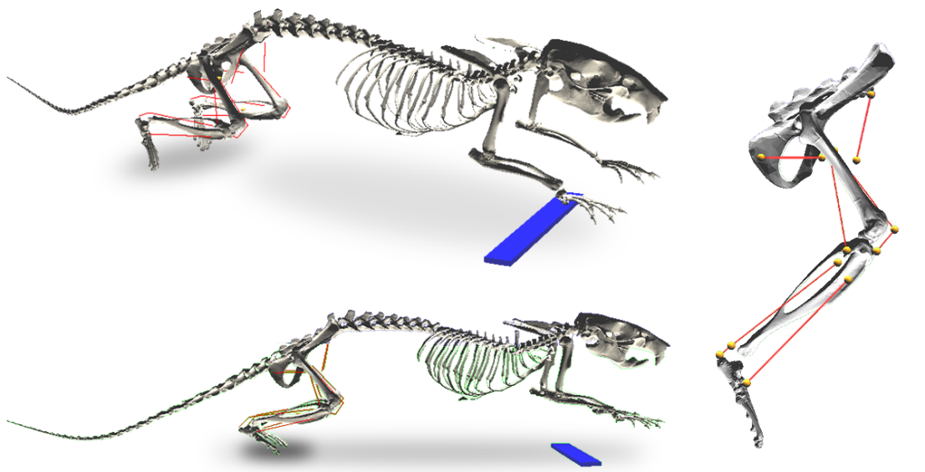

Figure 1 The rat model used by Hunt for modeling locomotion. Note the antagonistic muscle pairs at each joint. The blue bar represents a solid support that raises the static torso above the ground while moving.

The complex circuitry of CPGs is abstracted in many existing models even though their activity is still not fully understood (Guertin 2009; Markin et al. 2016). CPGs exploit characteristics of mutual inhibition which, through delicate interplay of synaptic parameters, causes two “halves” of the CPG system to oscillate. CPGs are increasingly used in models that control locomotion (Beer, Chiel, and Gallagher 1999; Ijspeert 2008; Chung and Dorothy 2010; S. O. Schrade et al. 2017; Duysens and Forner-Cordero 2019; Dutta et al. 2019). By including a single set of antagonist muscles at each joint, a simple one-to-one connection between the muscles and the CPG halves was possible. Hunt’s model used inverse kinematics to calculate the motoneuron signals necessary to generate joint motion and translated CPG neuron oscillation into joint oscillation.

Hunt’s model incorporated a hierarchical CPG system (McCrea and Rybak 2008) to coordinate joint motion. Feedback from muscle sensors allows researchers to compare stimulation protocols to optimize locomotion. Neural control of locomotion is abstracted into hierarchical layers composed of CPGs with a high order rhythm generator (RG) layer and a low level pattern formation (PF) layer. Oscillations in the RG layer cause the leg to alternate between stance and swing phase. Hunt’s model has a PF unit at each joint, oscillating between flexion and extension. Afferent feedback is transmitted from type Ia, Ib, and II fibers to the CPGs to modulate oscillation phase patterns.

The Hunt rat model applied a novel neural design approach that compartmentalized groups of neurons into algebraic subunits with known input-output relationships, called functional subnetworks (FSN) (Szczecinski, Hunt, and Quinn 2017a). The FSN approach reduces the complexity of a neural system by simplifying neuronal relationships into algebraic operations. This acts as an intermediary for relaying functional outputs when morphological components are not completely understood. Networks designed using the FSN approach ease the integration of morphological components with known functional relationships. This modular approach encourages expansion and development as new structures are described in the literature. FSN design has been used to control locomotion in robots modeled after a dog (Hunt, Szczecinski, and Quinn 2017) and a praying mantis (Szczecinski, Martin, et al. 2014).

A leg’s ability to generate propulsive and stabilizing forces is dependent on a complex interplay of muscle lines of action across multiple joints. Hunt’s model excludes muscles which span multiple joints, known as biarticular muscles (Cleland 1867). While monoarticular muscles primarily generate forces along the length of a bone segment, biarticular muscles are critical for generating transverse forces (Hof 2001). Utilizing the multi-level CPG hierarchy of McCrae and Rybak, a one-to-one connection between half-center neurons in the CPG and antagonistic muscles was possible. The inclusion of biarticular muscles introduces a design challenge when considering how a discrete, joint based control system can be generalized to coordinate contractions of muscles whose activity is not exclusive to a single joint. Work has already begun to address this design challenge through neural control but has not yet integrated a complete muscle set (Deng et al. 2019).

Neuromechanical models have been created in Animatlab, a simulation program that unites a physics engine with a neural design environment (Cofer et al. 2010). Animatlab is a vital tool that allows researchers to simultaneously design body components and the neurons which innervate them. Other common simulation programs for locomotion research include OpenSim (Seth et al. 2011) and even the 3D computer graphics software Blender. However, these alternatives lack the neural design component that is fundamental to understanding the underlying neural control of muscles. Hunt’s work laid the groundwork for a more complex model with more muscles and an expanded neural control system.

## Synergies

As a neural control system grows to accommodate additional muscles, optimizing parameter values for neurons and synapses becomes computationally intensive. Reducing the dimensionality of the parameter space reduces computation time and accelerates optimization techniques necessary for the implementation of the FSN method. Organizing muscles into groups whose contractions have temporal and spatial correlations is a biologically representative method of improving the computational efficiency of a control system (W. A. Lee 1984; Tresch, Saltiel, and Bizzi 1999).

The appeal of a muscle synergy control model lies in the reduced parameterization which would ease the computational complexity associated with designing neuromechanical control systems (Ting and Macpherson 2005; Aoi et al. 2013; Alessandro, Carbajal, and d’Avella 2014). Recently, synergy analysis has been used to assess patients’ muscular deficiency level and develop treatment plans for stroke survivors and patients with cerebral palsy (Steele, Rozumalski, and Schwartz 2015). Muscle synergy analysis has broad uses including viability in clinical, robotic, and sport analysis (Taborri, Agostini, et al. 2018).

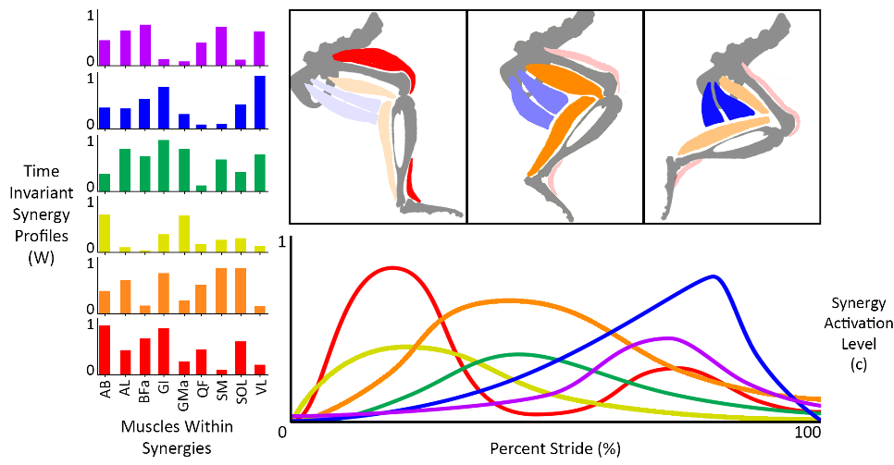The identification of muscle synergies relies on statistical methods to decompose electromyography (EMG) measurements from many muscles while completing a task. Multiple matrix factorization techniques have been used to characterize synergy profiles (Andrea d’Avella, Saltiel, and Bizzi 2003; Tresch, Cheung, and d’Avella 2006; Torres-Oviedo and Ting 2007; Taborri, Palermo, et al. 2018), with the most common being nonnegative matrix factorization (NNMF) (Ting et al. 2012; D. D. Lee and Seung 2001). In NNMF, rectified, low-pass filtered EMG recordings are decomposed into a set of spatial vectors, representing time invariant muscle activation profiles, and temporal vectors, representing the timing of synergy coactivation. The overall muscle activation for characterizes the relative activation of muscles in the hindlimb at a point in time and determines the kinetics that the leg produces. The temporal and spatial vectors derived from synergy decomposition form a linear decomposition of the overall muscle activation profile.

Figure 2 A conceptual example of synergy decomposition. Time invariant synergy profiles represent relative muscle activations. Synergy activation levels represent temporal activation of entire synergy groups.

Existing synergy decomposition methods use averaged EMG data which minimizes signal variability that may be important to developing robust synergy profiles across tasks and subjects (Ting et al. 2012; Steele, Tresch, and Perreault 2015). Evidence suggests that the body may simply strive to reduce EMG variability for task-relevant muscles while ignoring signals from other muscles (Francisco J. Valero-Cuevas, Venkadesan, and Todorov 2009; Cullins et al. 2014).

The synergy model has recently come under scrutiny as researchers have posited that synergies are less likely manifestations of physical neural systems and moreso optimal task-specific responses from the body (Perreault et al. 2008; Tresch and Jarc 2009; Kutch and Valero-Cuevas 2011). The task-specific focus of muscle synergy derivation does not mean that the model is unsuitable for robotic control, though, so long as the natural dynamics of the systems are considered within the task demands (A. d’Avella and Bizzi 2005; Max Berniker et al. 2009).

For synergies to be considered physically engrained in nervous system, it is expected that relative muscle activation within a synergy would remain consistent over time and across a variety of tasks. It has been theorized that synergies could be encoded in upstream neural connections in the form of torque profiles (T. S. Buchanan et al. 1986). Muscle synergies may function as a type of lookup table for the central nervous system (CNS) to assemble task responses based on a pre-defined “toolset” (McKay and Ting 2012). This is supported in primate upper limb work which demonstrates a preferential torque direction for individual muscles (i.e. flexors are more sensitive to flexion) (Kurtzer et al. 2006). An analysis of bicyclists and runners indicated that forces are redistributed between muscles over time while maintaining consistent overall torque profiles (Savelberg and Meijer 2003). Motorneuron clusters have been mapped in the rat spinal cord (Nicolopoulos‐Stournaras and Iles 1983) and can be stimulated to induce synergy-based locomotion (Wenger et al. 2016). Recent work suggests that the nervous system tweaks the weighting of different muscles within synergies at short timescales and for different tasks (Ranganathan et al. 2016; Chia Bejarano et al. 2017). The nervous system distributes forces to antagonist muscles to maintain stability rather than increasing contraction of a single muscle (Schipplein and Andriacchi 1991). This implies that the nervous system may actually control individual responses to coordinate muscle activation.

Evidence suggests that the CNS may deviate from expected synergistic responses by prioritizing muscle activation that reduces internal stress, even when it has the option to delegate muscle stresses to redundant muscles instead (Alessandro et al. 2018). Perhaps the infinite solution space offered by muscle redundancy is narrowed by task constraints, simplifying the mapping of neural connections that modulate muscle contractions (F. J. Valero-Cuevas et al. 2015; Sandercock et al. 2018). The pathway for uniting our generalized muscle model with the traditional neural control regime could stem from a hardcoded implementation of the muscle synergy model.

## Perturbations

Nominal walking patterns are kinematic profiles (joint angles, torque patterns, muscle activation, etc.) that describe limb motion during unimpeded flat ground walking at a self-selected speed. The development of nominal models are useful because they are relatively easy to create and there is a wealth of nominal metrics available in the literature. Ultimately, nominal patterns reveal little about the dynamic interplay between the nervous system, body, and environment because they fail to activate afferent feedback pathways that respond to environmental uncertainty. Adding perturbations to kinematic responses, such as obstacles to jump over or holes to fall into, trigger different actions. Analyzing these reflexes, as they manifest in joint kinematics and muscle EMG patterns, can suggest new pathways in the hierarchical structure of walking systems.

# Completed Work and Remaining Work

* A complete hindlimb model with physiological muscle paths and attachments
* Physiological muscle parameters based on force-length and stimulus-tension relationships where available in the literature
* Kinematic model validation through the comparison of muscle moment arm profiles over stride
* Implementation of optimization equations from the literature for decomposing joint torque profiles into individual muscle force profiles

## Aim 1 - Expand a neuromechanical model of a rat hindlimb to include a complete musculature with physiological muscle paths

### Completed Work

*Physiologically relevant muscle attachment points*

Figure 3 An example of using Greene's anatomical drawings to guide the muscle paths in Animatlab

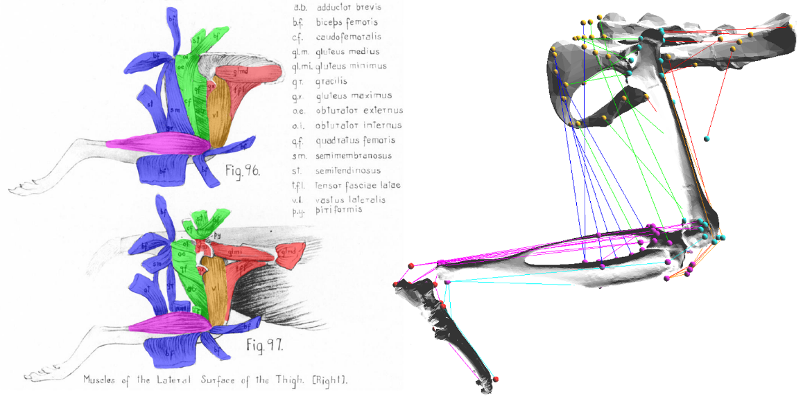

A hindlimb model that reliably predicts muscle forces is entirely dependent on the accurate representation of muscle properties. Prior work, which simplified the musculature to an antagonistic muscle pair for each joint, is not a feasible model for focusing on grouped muscle activation. Three-dimensional kinematic models of four legged animals have been created for rats (Will L. Johnson et al. 2008; Wei, Pai, and Tresch 2018; Thota et al. 2005), mice (Charles et al. 2016), and cats (Ekeberg and Pearson 2005).

At the outset of muscle expansion, efforts were made to directly apply a 3D point cloud from the work of Johnson et al. (Will L. Johnson et al. 2008) onto the hindlimb bone meshes used by Hunt. This work included the xyz coordinates for origin and insertion points for thirty-eight muscles in the rat hindlimb with respect to bony landmarks. In other work, optimization techniques have been used to apply these coordinates to bone meshes in programs that facilitate muscle wrapping (Wei, Pai, and Tresch 2018). The application of Johnson’s attachment points were presented at Living Machines 2018 (Young, Hunt, and Quinn 2018).

Johnson’s work was enticing for its potential to ease the design process but was unusable for two reasons: poorly defined bony landmarks in Johnson’s work necessitated hand-tuning to fit point clouds to bone meshes and including only the insertion and origin was not comprehensive enough to prevent muscles from passing through bone. Muscle attachment points are also stationary relative to bone coordinate frames, limiting the ability to model muscle movement over bone. For muscles that wrap closely over bones (such as the vastii muscles across the front of the knee), muscle paths include via points to avoid pass through.

Instead of using Johnson’s point cloud, muscle paths were hand-guided based on the descriptions from E.C. Greene’s 1955 publication Anatomy of the Rat (Greene 1955). Muscle paths were developed by integrating anatomical diagrams and descriptions for thirty-eight muscles in the hindlimb. Special care was taken to identify bony landmarks on the bone meshes in order to guide muscles along sensible anatomical paths. Muscles were reduced to a single line of action to approximate the muscle’s line of action.

*Dynamic Muscle Moment Arm Profiles*

Muscle moment arms have been analyzed in the literature as a way of understanding the functional effect that muscles have about joints (Visser et al. 1990; S. W. Lee et al. 2008; Williams et al. 2008; Yeo et al. 2011; Charles et al. 2016). In small animals, measuring muscle moment arms is especially difficult because small errors can magnify the torque generating capabilities of muscles. For this reason, using X-Ray imaging or implanting physical markers under the skin can aid in the generation of accurate moment arm profiles during locomotion (An et al. 1984).

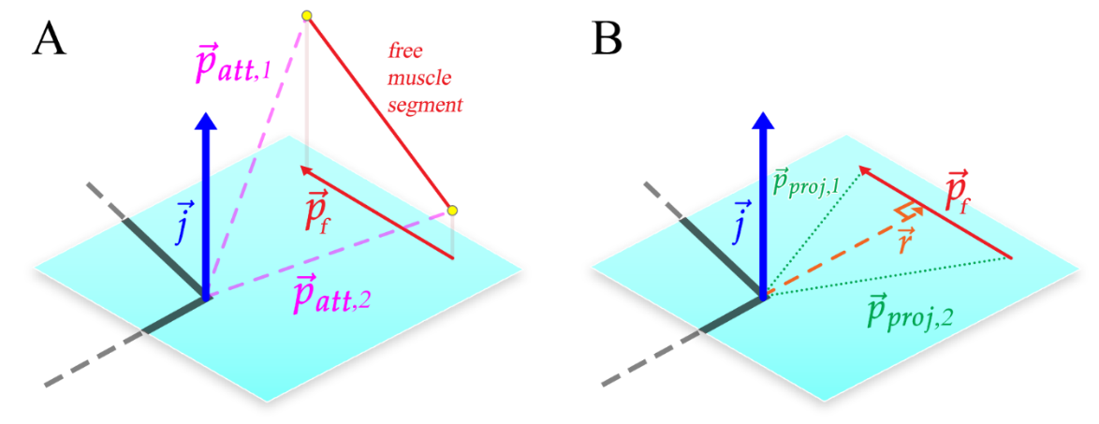

Figure 5 Calculating the muscle moment arm, r. The plane of interest and its coordinate system is defined by the joint center and the joint axis representing flexion/extension (blue). Joint axes are defined using the same convention as Charles and Johnson. Orthogonal joint axes represent abduction/adduction, and inversion/eversion. The free muscle segment that connects the adjacent bone segments (monoarticular muscles) or to the bone segment after the next (biarticular muscles) is projected onto the plane of interest. This projected free segment is called. The muscle moment arm, the signed magnitude of , is calculated from  and  as described in the text.

Calculating moment arms from fundamental principles is a useful tool to analyze the force generating capabilities of specific muscles in the model. Additionally, this is a useful metric whereby the model can be validated against existing hindlimb models. This work led to a publication in the Journal of Biomimetics (Young et al. 2019).

Muscle moment arms are developed by projecting muscle paths onto a plane of interest and then measuring the shortest distance from the joint center to the free muscle segment. In the case of 2D walking, the plane of interest is the sagittal plane. Wrapping muscles contain via points that are stationary relative to one another when in the same bone coordinate system. Moment arms were calculated for the muscle segment that actively undergoes contraction during walking.

### Remaining Work

The Animatlab model must be expanded to include another leg if we want the model to be capable of locomotion.

### Publications

Analyzing Muscle Moment Arms in a Hindlimb Model (Young et al. 2019)

## Aim 2 – Investigate muscle activation strategies that meet torque demands under nominal and perturbed conditions

### Completed Work

Animatlab uses a two-compartment linear Hill muscle model (Hill Archibald Vivian 1938) for representing tension. The original model is characterized by an elastic element in parallel with a contractile-elastic element. The series elastic element represents the force-length properties of the muscle while the contractile-elastic element captures the force-velocity components of the muscle. Work by Zajac (Zajac 1989) formalizes Hill’s model into the form used in Animatlab and incorporates a parallel damping element to enhance modeling stability.

Figure 4 The linear Hill muscle model used by Animatlab.

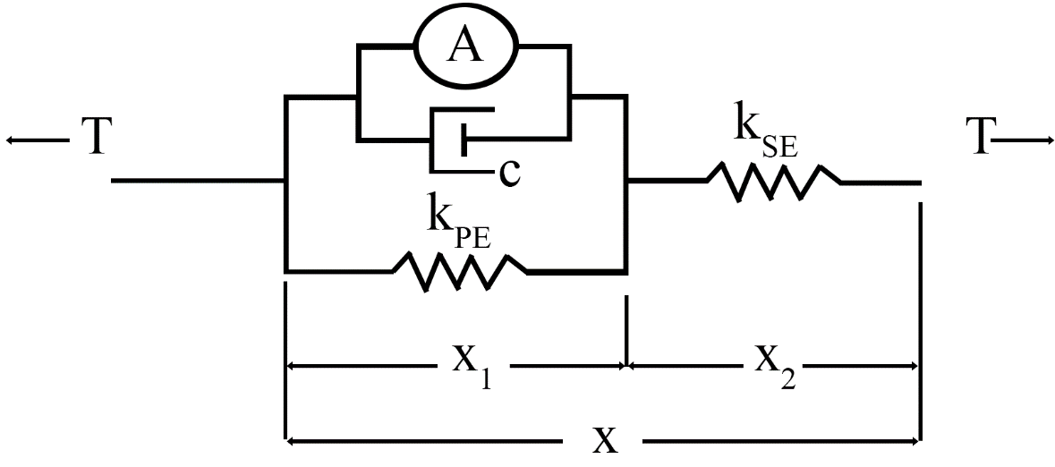

,

where T is muscle tension,  is serial element stiffness,  is parallel element stiffness, L is muscle length, c is the muscle damping factor, is muscle activation in Newtons, and  is a dimensionless length-tension modifier.

*Physiological Muscle Parameters*

Computational models rely on parameter values that are not currently found in the literature. No work has been found that documents Hill muscle parameters for every muscle in the rat hindlimb. Work by Johnson et al. (W. L. Johnson et al. 2011) and Eng et al. (Eng et al. 2008) have described physiological parameters (muscle mass, optimal muscle length, etc.) for rat hindlimb muscles. By combining the physiological parameters from Johnson and Eng with the modeling equations from Zajac, it is possible to approximate Hill muscle parameters for an Animatlab model. Hill parameters were determined by analyzing the response of the length tension and stimulus tension curves and back solving for the parameters.

* + - * 1. The Length-Tension Curve

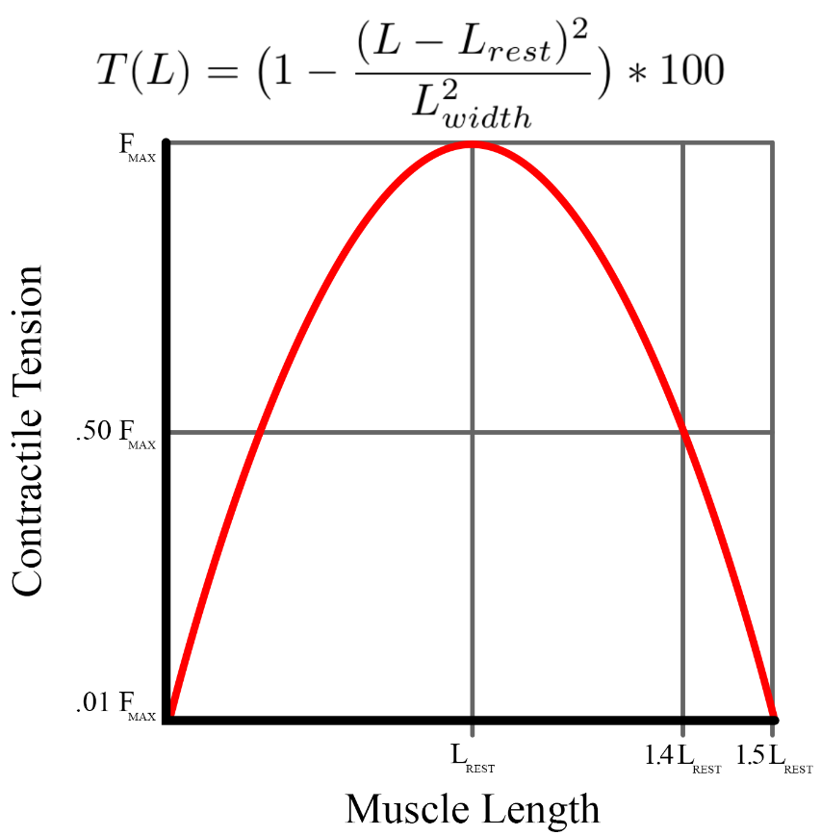

Figure 6 The length-tension curve as modeled by Animatlab

The length-tension (LT) curve relates a muscle’s force-generating capabilities at various isometric lengths. At an optimal resting length, a muscle is able to produce maximal force. This maximal force is different for every muscle and depends on parameters such as its pennation angle, mass, and physiological cross sectional area (PCSA) (Hoy, Zajac, and Gordon 1990). Deviations from the optimal resting length reduce the force that the muscle can exert, although some research suggests that muscles operate at intentionally longer lengths in order to accommodate the shortening effects of the musculo-tendon complex (Ettema and Huijing 1989).

In addition to the active muscle force generated by contracting muscle fibers, muscles have an inherent passive force that is generated when the muscle is extended beyond its optimal resting length. These passive forces tend to be small (Rode et al. 2009) and were not considered in Hunt’s model. They have, however, been introduced in the current model in an effort to make a more physiologically relevant leg model.

Animatlab uses a simplified LT curve equation,

,

where L is the muscle length,  is the tension at a specific length, Lwidth is the muscle width, and Lrest is the resting muscle length. Assuming that the muscle width is half the resting length (due to the symmetry of the Animatlab curve), it is possible to determine the values of the parallel and series spring elements for the muscle at equilibrium. Using the steady state Hill equation, the equilibrium () force relationship becomes,





.

Using optimal force and resting lengths from Johnson et al. (W. L. Johnson et al. 2011), the three simultaneous equations were solved for three unknowns: ,, and .







Solutions to these equations were developed from Matlab’s function solver, producing positive-value parameters for each muscle in the system. The solution set with the  value closest to  was chosen for each muscle and injected into an Animatlab project file.

* + - * 1. 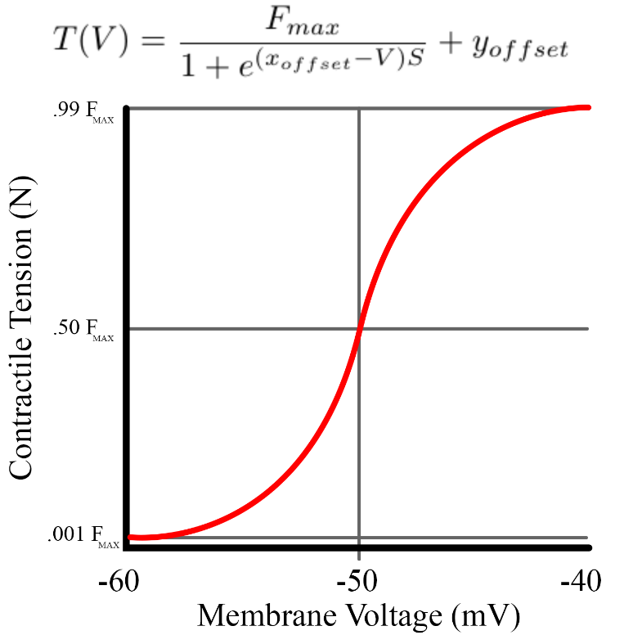The Stimulus-Tension (ST) Curve

Figure 7 The ST curve as modeled in Animatlab. Steepness was calculated to meet the boundary conditions described in the text.

The stimulus-tension (ST) curve relates muscle membrane potential to muscle force output. ST curves exist in the literature for a number of hindlimb muscles, but not all (Jarc, Berniker, and Tresch 2013). In the Hill equation, the ST relationship is represented by the parameter Am. This model does not capture many of the nuances associated with the stimulation mechanics of muscles, such as twitch mechanics (Spector et al. 1980) or the time delay between EMG signal onset and measured force (Thomas S. Buchanan et al. 2004; Corcos et al. 1992).

Animatlab uses a simplified ST equation,

,

where  is the tension at a specific motorneuron voltage in Newtons, Fmax is the maximum muscle force, xoffset is the offset for the sigmoid, yoffset is the force offset for the sigmoid, V is the motorneuron voltage, and S is the steepness of the curve. The model assumes a constant xoffset of -50mV and yoffset of 0 N.

Previous work has established a neural design process that reduces complex networks into functional subnetworks (FSN) capable of coordinating locomotion (Szczecinski, Hunt, and Quinn 2017a). Neurons in FSN models operate in a set voltage range of -60 to -40mV. For the current model, it is assumed that at -60mV, the muscle generates force equal to .5% Fmax. At -40mV, the muscle generates 99% Fmax. These boundary conditions determine the necessary steepness of the curve and the x offset was set to -50mV.

There is evidence to suggest that there is a linear relationship between integrated EMG signals and the isometric force a muscle generates (Bouisset 1973; Lippold 1952). This is an attractive characteristic because it allows for inverse calculation of the integrated EMG signal. Realistically, though, a robust system would account for EMG variability (Steele, Tresch, and Perreault 2015). Additionally, motor stimulation responses can lead to unpredictable force outputs, making it more useful to consider the output forces as a probability space rather than a direct one-to-one activation (M. Berniker et al. 2016).

*Torque*

Evidence suggests that there is an approximately linear relationship between normalized EMG and isometric torque generation in muscle about the human elbow (T. S. Buchanan et al. 1986). Stance phase torque profiles have been measured for rats walking on inclined and flat surfaces (Andrada et al. 2013). Hunt developed a simulation in Simulink that incorporated leg segment inertia to model swing phase torque profiles (Hunt et al. 2014). Interpolation of alternating stance and swing torque profiles formed a single, idealized stride torque profile.

*Passive Torque*

Passive torque in the joints arises from two sources: ground reaction forces and passive muscle forces. With muscle parameters determined and moment arm profiles well defined, passive muscle torques were calculated for all joints over stride. To determine passive muscle torque contributions, torque generated by ground reaction forces (GRFs) was subtracted from the overall torque profile. Ground reaction torques were developed by treating the leg as a multi-segmented arm with GRFs at the end effector (Murray, Li, and Sastry 1994). Ground reaction torques were calculated by computing the spatial manipulator Jacobian (), an operator for converting end effector forces into torques at the joints. For a three segment arm, the spatial manipulator Jacobian is a 63 matrix with columns of the form:



where  represents the column number,  represents the joint axis vector of joint  and  represents the joint's position in global coordinates. End effector forces are calculated using the three dimensional ground reaction force data from the literature (Muir and Whishaw 1999). With the spatial manipulator Jacobian and the ground reaction forces (), sagittal plane ground reaction torque in all three joints can be calculated using,

.

Active joint torque is the summation of individual muscle torques about each joint. With a method for calculating muscle moment arms and complete torque profiles, the final challenge is to calculate the muscle forces necessary to generate the complete torque profile. However, an infinite combination of force profiles act as the solution space making the outright distribution of muscle forces difficult.

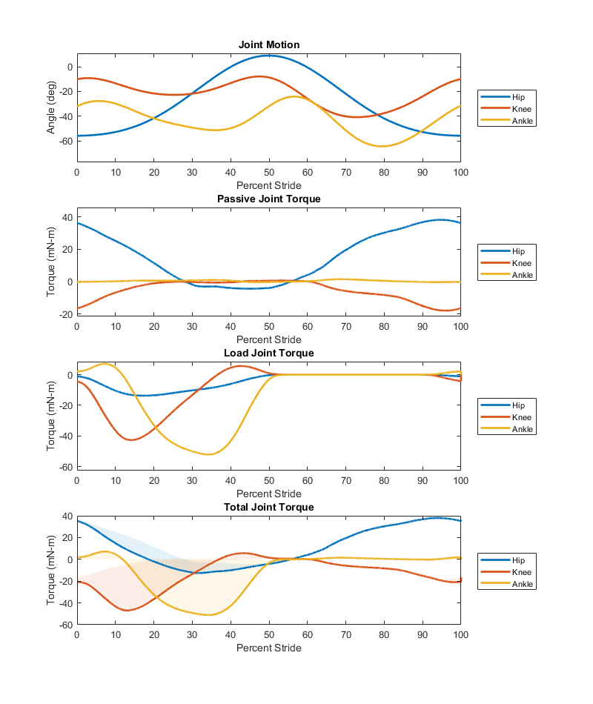

Figure 8 Joint torque generated by motion defined by the top subplot. Passive joint torque is generated by the muscle passive properties. Load joint torque is generated by the weight of the animal as it comes in contact with the ground (only during stance). The total joint torque is shown in the bottom plot with shaded regions indicating the impact of load torque on the passive muscle torque waveforms.

*Optimizing the force*

Optimizing muscle forces profiles can be accomplished using an inverse or forward dynamics approach in the form of static or dynamic optimization, respectively. Dynamic optimization considers factors such as muscle physiology and physiological variables in the form of nonlinear, time variant equations. Static optimization is highly dependent on accurate kinematic data and is inherently time-independent, making it difficult to account for muscle physiology (Anderson and Pandy 2001a). Dynamic optimization can necessitate thousands of hours of CPU processing time (Anderson and Pandy 2001b) and does not offer enough of a tangible benefit over static optimization (Anderson and Pandy 2001a). For this reason, force optimization has been carried out using static optimization methods while making efforts to consider the muscle physiology as much as possible.

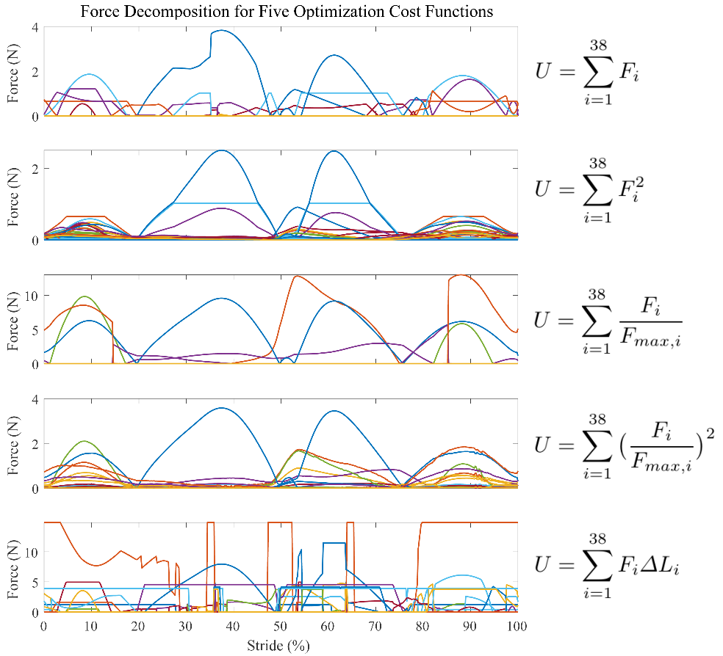

Figure 9 Force profiles as a result of using five different optimization cost functions. In all instances, the cost function, **U**, is minimized while maintaining the torque demands of the system.

A number of different optimization protocols have been used to determine force profiles for individual muscles. Some processes minimize forces (Pedotti, Krishnan, and Stark 1978; Penrod, Davy, and Singh 1974), some minimize muscle stress (Crowninshield and Brand 1981), some minimize muscle activation (Kaufman et al. 1991), and some minimize fatigue (Prilutsky and Zatsiorsky 2002). The optimization method is affected by the number of degrees of freedom the joint must control (Thomas S. Buchanan and Shreeve 1996). An important factor for choosing an optimization criteria is determining which physiological quantity is the most relevant to the dynamics in the system (Hardt 1978). While there has not been a definitive declaration of which method is the most universally effective, the force distribution characteristics of each optimization method have been compared (Herzog and Leonard 1991).

Initially, linear optimization was applied at each time step during a single stride by minimizing the summed forces that, when multiplied by the instantaneous moment arms, equaled the instantaneous torque. Although this is possible since the problem is linear, this optimization method delivers solutions that fall on an “optimization corner” (Crowninshield and Brand 1981), causing jagged force profiles that are not indicative of actual muscle contractions.

Work has now transitioned to static optimization with an interchangeable cost function. By implementing cost functions from (Pedotti, Krishnan, and Stark 1978) and (Seireg and Arvikar 1973), a suitable cost function has been identified that relates muscle forces to their maximum values squared. This produces continuous force profiles with low function error.

### Remaining Work

Ultimately, model development has been a balance of striving for physiological accuracy while navigating the constraints of Animatlab. The Hill model is reductive because it does not take into account some interesting features of muscle, such as the asymmetrical lengthening/shortening profile of the force velocity curve (Murphy and Beardsley 1974; Yeo et al. 2013) or the impact of tendon tension on force magnitudes (Pearlman, Roach, and Valero-Cuevas 2004). This model could be improved through the inclusion of these extra features, but at the cost of the neural interface that Animatlab offers. A number of muscle model equations were studied over the course of development (Thelen 2003; Brown, Scott, and Loeb 1996; Lloyd and Besier 2003) to better understand how different subsets of the muscle force equations coordinate to induce contractions.

Now that muscle force profiles have been developed through optimization, the ST curve equation can be solved to find the neural stimulation necessary to induce the forces. Work by Thelen and Lloyd suggest nonlinear relationships between activation and EMG signals. The underlying EMG signals that elicit these forces can be compared to muscle recordings gathered by research collaborators.

### Publications

There are no existing publications from this aim yet, but there is enough work to collate into a publication with access to experimental data. Possible publications include:

* A publication comparing the modelled EMG results to actual EMG measurements in the rat. This could also feed the EMG signals back into the model and test leg kinematics.
* A publication comparing of different optimization functions on the force profiles, including the impact that passive forces play in force distribution

## Aim 3 – Create novel simulation tools for neuromechanical simulations focused on large-scale neural network design

### Completed Work

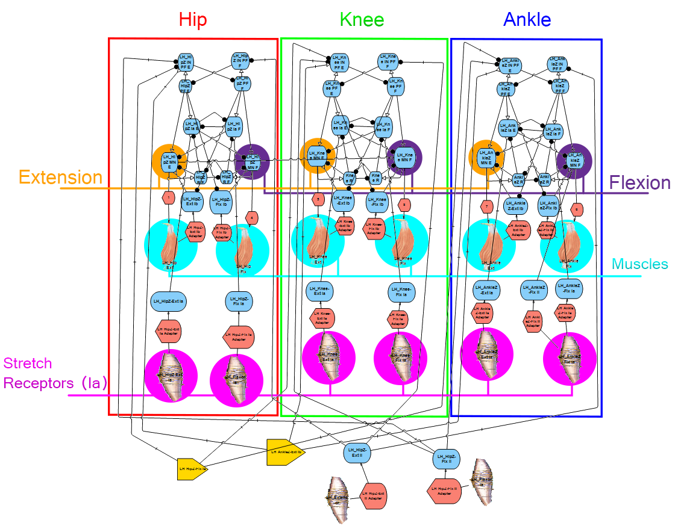This aim integrates the kinematic work of the previous aims with the synthetic nervous system design paradigm established in prior work. Models of the nervous system pale in comparison to the actual nervous system of vertebrates, with reduced numbers of neurons and abstractions from their nonlinear nature to ease computational costs. As the rat model becomes more complex through the addition of muscles, the nervous system must grow to accommodate them. Hunt's model, which only utilized six muscles and had one-to-one muscle-to-CPG connections, used over 40 neurons. A model that features thirty-eight muscles per leg, many of which are biarticular, will require a more comprehensive method of system building than simply building by hand.

Figure 10 The FSN of Hunt's model. This model is broken into three discrete joint sections which are subdivided into flexion/extension halves. As the musculature of the system scales up, this system becomes much more complex.

While Animatlab is a crucial part of the FSN approach, it has many weaknesses that hinder advancements in the field. Animatlab is no longer supported by the developer which makes its functionality under software updates increasingly unlikely. The program is compiled in the C programming language which makes it difficult to understand what is happening "under the hood" of the program or to make modifications. Additionally, navigating the user interface is tenuous when expanding the size of a nervous system and lacks basic functionality such as an "undo" button. In the physics module, it is impossible to wrap muscles around bone, prevent muscle pass-through, or create muscle insertion lines along surfaces. The basic principles underlying the FSN approach are sound and ripe for research development but the field will soon outgrow Animatlab.

Alternatives for Animatlab must be developed to advance the field of FSN design. As a first step in creating a UI alternative, a Matlab project has been developed that allows user to automatically generate FSN subsystems to expedite system design. An FSN "toolbox", where the synaptic connections are automatically calculated, allows users to generate large-scale networks with minimal effort. This program, called Canvas, allows for nervous system design and component editing but still requires user to export the system into an Animatlab file. This is a valuable first step to understanding how Animatlab formats information and what information is necessary for the creation of an alternative program.

Python is a programming language with a wealth of community resources for project development and has been deployed in millions of research and commercial projects. Most notably, Python contains a repository of open-source packages related to creating things in physics environments and generating GUI's. An Animatlab alternative developed in Python would be an asset to the field of FSN design and ease the design process for future generations of FSN researchers. This aim would revolve around creating a functional Animatlab alternative in Python and testing its use on the rat model to address persistent research questions.

### Remaining Work

### Publications

# References

Alessandro, Cristiano, Juan Pablo Carbajal, and Andrea d’Avella. 2014. “A Computational Analysis of Motor Synergies by Dynamic Response Decomposition.” *Frontiers in Computational Neuroscience* 7. https://doi.org/10.3389/fncom.2013.00191.

Alessandro, Cristiano, Benjamin A. Rellinger, Filipe O. Barroso, and Matthew C. Tresch. 2018. “Adaptation after Vastus Lateralis Denervation in Rats Suggests Neural Regulation of Joint Stresses and Strains.” *BioRxiv*, January, 1–18. https://doi.org/10.1101/312488.

An, K. N., K. Takahashi, T. P. Harrigan, and E. Y. Chao. 1984. “Determination of Muscle Orientations and Moment Arms.” *Journal of Biomechanical Engineering* 106 (3): 280. https://doi.org/10.1115/1.3138494.

Anderson, Frank C., and Marcus G. Pandy. 2001a. “Static and Dynamic Optimization Solutions for Gait Are Practically Equivalent.” *Journal of Biomechanics* 34 (2): 153–61. https://doi.org/10.1016/S0021-9290(00)00155-X.

———. 2001b. “Dynamic Optimization of Human Walking.” *Journal of Biomechanical Engineering* 123 (5): 381–90. https://doi.org/10.1115/1.1392310.

Andrada, E., J. Mämpel, A. Schmidt, M.S. Fischer, A. Karguth, and H. Witte. 2013. “From Biomechanics of Rats’ Inclined Locomotion to a Climbing Robot.” *International Journal of Design & Nature and Ecodynamics* 8 (3): 192–212. https://doi.org/10.2495/DNE-V8-N3-192-212.

Aoi, Shinya, Takahiro Kondo, Naohiro Hayashi, Dai Yanagihara, Sho Aoki, Hiroshi Yamaura, Naomichi Ogihara, et al. 2013. “Contributions of Phase Resetting and Interlimb Coordination to the Adaptive Control of Hindlimb Obstacle Avoidance during Locomotion in Rats: A Simulation Study.” *Biological Cybernetics* 107 (2): 201–16. https://doi.org/10.1007/s00422-013-0546-6.

Avella, A. d’, and E. Bizzi. 2005. “Shared and Specific Muscle Synergies in Natural Motor Behaviors.” *Proceedings of the National Academy of Sciences* 102 (8): 3076–81. https://doi.org/10.1073/pnas.0500199102.

Avella, Andrea d’, Philippe Saltiel, and Emilio Bizzi. 2003. “Combinations of Muscle Synergies in the Construction of a Natural Motor Behavior.” *Nature Neuroscience* 6 (3): 300–308. https://doi.org/10.1038/nn1010.

Beer, Randall D., Hillel J. Chiel, and John C. Gallagher. 1999. “Evolution and Analysis of Model CPGs for Walking: II. General Principles and Individual Variability.” *Journal of Computational Neuroscience* 7 (2): 119–47. https://doi.org/10.1023/A:1008920021246.

Beer, Randall D., Roger D. Quinn, Hillel J. Chiel, and Roy E. Ritzmann. 1997. “Biologically Inspired Approaches to Robotics: What Can We Learn from Insects?” *Commun. ACM* 40 (3): 30–38. https://doi.org/10.1145/245108.245118.

Berniker, M., A. Jarc, K. Kording, and M. Tresch. 2016. “A Probabilistic Analysis of Muscle Force Uncertainty for Control.” *IEEE Transactions on Biomedical Engineering* 63 (11): 2359–67. https://doi.org/10.1109/TBME.2016.2531083.

Berniker, Max, Anthony Jarc, Emilio Bizzi, and Matthew C. Tresch. 2009. “Simplified and Effective Motor Control Based on Muscle Synergies to Exploit Musculoskeletal Dynamics.” *Proceedings of the National Academy of Sciences*, April, 6. https://doi.org/10.1073/pnas.0901512106.

Bouisset, S. 1973. “EMG and Muscle Force in Normal Motor Activities.” *New Concepts of the Motor Unit, Neuromuscular Disorders, Electromyographic Kinesiology* 1: 547–83. https://doi.org/10.1159/000394059.

Brown, Ian E., Stephen H. Scott, and Gerald E. Loeb. 1996. “Mechanics of Feline Soleus: II Design and Validation of a Mathematical Model.” *Journal of Muscle Research & Cell Motility* 17 (2): 221–33. https://doi.org/10.1007/BF00124244.

Bryden, John, and Netta Cohen. 2008. “Neural Control of Caenorhabditis Elegans Forward Locomotion: The Role of Sensory Feedback.” *Biological Cybernetics* 98 (4): 339–51. https://doi.org/10.1007/s00422-008-0212-6.

Buchanan, T. S., D. P. Almdale, J. L. Lewis, and W. Z. Rymer. 1986. “Characteristics of Synergic Relations during Isometric Contractions of Human Elbow Muscles.” *Journal of Neurophysiology* 56 (5): 1225–41. https://doi.org/10.1152/jn.1986.56.5.1225.

Buchanan, Thomas S., David G. Lloyd, Kurt Manal, and Thor F. Besier. 2004. “Neuromusculoskeletal Modeling: Estimation of Muscle Forces and Joint Moments and Movements From Measurements of Neural Command.” *Journal of Applied Biomechanics* 20 (4): 367–95.

Buchanan, Thomas S., and David A. Shreeve. 1996. “An Evaluation of Optimization Techniques for the Prediction of Muscle Activation Patterns During Isometric Tasks.” *Journal of Biomechanical Engineering* 118 (4): 565–74. https://doi.org/10.1115/1.2796044.

Buschmann, Thomas, Alexander Ewald, Arndt von Twickel, and Ansgar Büschges. 2015. “Controlling Legs for Locomotion—Insights from Robotics and Neurobiology.” *Bioinspiration & Biomimetics* 10 (4): 041001. https://doi.org/10.1088/1748-3190/10/4/041001.

Chang, Sarah R., Mark J. Nandor, Lu Li, Rudi Kobetic, Kevin M. Foglyano, John R. Schnellenberger, Musa L. Audu, Gilles Pinault, Roger D. Quinn, and Ronald J. Triolo. 2017. “A Muscle-Driven Approach to Restore Stepping with an Exoskeleton for Individuals with Paraplegia.” *Journal of NeuroEngineering and Rehabilitation* 14 (1): 48. https://doi.org/10.1186/s12984-017-0258-6.

Charles, James P., Ornella Cappellari, Andrew J. Spence, Dominic J. Wells, and John R. Hutchinson. 2016. “Muscle Moment Arms and Sensitivity Analysis of a Mouse Hindlimb Musculoskeletal Model.” *Journal of Anatomy* 229 (4): 514–35. https://doi.org/10.1111/joa.12461.

Chia Bejarano, Noelia, Alessandra Pedrocchi, Antonio Nardone, Marco Schieppati, Walter Baccinelli, Marco Monticone, Giancarlo Ferrigno, and Simona Ferrante. 2017. “Tuning of Muscle Synergies During Walking Along Rectilinear and Curvilinear Trajectories in Humans.” *Annals of Biomedical Engineering* 45 (5): 1204–18. https://doi.org/10.1007/s10439-017-1802-z.

Chiel, Hillel J., and Randall D. Beer. 1997. “The Brain Has a Body: Adaptive Behavior Emerges from Interactions of Nervous System, Body and Environment.” *Trends in Neurosciences* 20 (12): 553–57. https://doi.org/10.1016/S0166-2236(97)01149-1.

Chiel, Hillel J., Lena H. Ting, Örjan Ekeberg, and Mitra J. Z. Hartmann. 2009. “The Brain in Its Body: Motor Control and Sensing in a Biomechanical Context.” *Journal of Neuroscience* 29 (41): 12807–14. https://doi.org/10.1523/JNEUROSCI.3338-09.2009.

Chung, Soon-Jo, and Michael Dorothy. 2010. “Neurobiologically Inspired Control of Engineered Flapping Flight.” *Journal of Guidance, Control, and Dynamics* 33 (2): 440–53. https://doi.org/10.2514/1.45311.

Cleland, John. 1867. “On the Actions of Muscles Passing over More than One Joint.” *Journal of Anatomy and Physiology* 1 (1): 85–93.

Cofer, David, Gennady Cymbalyuk, James Reid, Ying Zhu, William J. Heitler, and Donald H. Edwards. 2010. “AnimatLab: A 3D Graphics Environment for Neuromechanical Simulations.” *Journal of Neuroscience Methods* 187 (2): 280–88. https://doi.org/10.1016/j.jneumeth.2010.01.005.

Corcos, Daniel M., Gerald L. Gottlieb, Mark L. Latash, Gil L. Almeida, and Gyan C. Agarwal. 1992. “Electromechanical Delay: An Experimental Artifact.” *Journal of Electromyography and Kinesiology* 2 (2): 59–68. https://doi.org/10.1016/1050-6411(92)90017-D.

Crowninshield, Roy D., and Richard A. Brand. 1981. “A Physiologically Based Criterion of Muscle Force Prediction in Locomotion.” *Journal of Biomechanics* 14 (11): 793–801. https://doi.org/10.1016/0021-9290(81)90035-X.

Cullins, Miranda J., Kendrick M. Shaw, Jeffrey P. Gill, and Hillel J. Chiel. 2014. “Motor Neuronal Activity Varies Least among Individuals When It Matters Most for Behavior.” *Journal of Neurophysiology* 113 (3): 981–1000. https://doi.org/10.1152/jn.00729.2014.

Deng, Kaiyu, Nicholas S. Szczecinski, Dirk Arnold, Emanuel Andrada, Martin S. Fischer, Roger D. Quinn, and Alexander J. Hunt. 2019. “Neuromechanical Model of Rat Hindlimb Walking with Two-Layer CPGs.” *Biomimetics* 4 (1): 21. https://doi.org/10.3390/biomimetics4010021.

Dutta, Sourav, Abhinav Parihar, Abhishek Khanna, Jorge Gomez, Wriddhi Chakraborty, Matthew Jerry, Benjamin Grisafe, Arijit Raychowdhury, and Suman Datta. 2019. “Programmable Coupled Oscillators for Synchronized Locomotion.” *Nature Communications* 10 (1): 1–10. https://doi.org/10.1038/s41467-019-11198-6.

Duysens, Jacques, and Arturo Forner-Cordero. 2019. “A Controller Perspective on Biological Gait Control: Reflexes and Central Pattern Generators.” *Annual Reviews in Control*, April. https://doi.org/10.1016/j.arcontrol.2019.04.004.

Ekeberg, Örjan, and Keir Pearson. 2005. “Computer Simulation of Stepping in the Hind Legs of the Cat: An Examination of Mechanisms Regulating the Stance-to-Swing Transition.” *Journal of Neurophysiology* 94 (6): 4256–68. https://doi.org/10.1152/jn.00065.2005.

Eng, Carolyn M., Laura H. Smallwood, Maria Pia Rainiero, Michele Lahey, Samuel R. Ward, and Richard L. Lieber. 2008. “Scaling of Muscle Architecture and Fiber Types in the Rat Hindlimb.” *Journal of Experimental Biology* 211 (14): 2336–45. https://doi.org/10.1242/jeb.017640.

Ettema, Gertjan J. C., and Peter A. Huijing. 1989. “Properties of the Tendinous Structures and Series Elastic Component of EDL Muscle-Tendon Complex of the Rat.” *Journal of Biomechanics* 22 (11): 1209–15. https://doi.org/10.1016/0021-9290(89)90223-6.

Fischer, Martin S., Nadja Schilling, Manuela Schmidt, Dieter Haarhaus, and Hartmut Witte. 2002. “Basic Limb Kinematics of Small Therian Mammals.” *Journal of Experimental Biology* 205 (9): 1315–38.

Greene, E. C. 1955. *Anatomy of the Rat.* New York: Hafner Publishing Co. https://www.cabdirect.org/cabdirect/abstract/19561405416.

Guertin, Pierre A. 2009. “The Mammalian Central Pattern Generator for Locomotion.” *Brain Research Reviews* 62 (1): 45–56. https://doi.org/10.1016/j.brainresrev.2009.08.002.

Hardt, D. E. 1978. “Determining Muscle Forces in the Leg During Normal Human Walking—An Application and Evaluation of Optimization Methods.” *Journal of Biomechanical Engineering* 100 (2): 72–78. https://doi.org/10.1115/1.3426195.

Herzog, W., and T. R. Leonard. 1991. “Validation of Optimization Models That Estimate the Forces Exerted by Synergistic Muscles.” *Journal of Biomechanics*, Proceedings of the NASA Symposium on the Influence of Gravity and Activity on Muscle and Bone, 24 (January): 31–39. https://doi.org/10.1016/0021-9290(91)90375-W.

Hill Archibald Vivian. 1938. “The Heat of Shortening and the Dynamic Constants of Muscle.” *Proceedings of the Royal Society of London. Series B - Biological Sciences* 126 (843): 136–95. https://doi.org/10.1098/rspb.1938.0050.

Hof, A. L. 2001. “The Force Resulting from the Action of Mono- and Biarticular Muscles in a Limb.” *Journal of Biomechanics* 34 (8): 1085–89. https://doi.org/10.1016/S0021-9290(01)00056-2.

Hooper, Scott L., Christoph Guschlbauer, Marcus Blümel, Philipp Rosenbaum, Matthias Gruhn, Turgay Akay, and Ansgar Büschges. 2009. “Neural Control of Unloaded Leg Posture and of Leg Swing in Stick Insect, Cockroach, and Mouse Differs from That in Larger Animals.” *Journal of Neuroscience* 29 (13): 4109–19. https://doi.org/10.1523/JNEUROSCI.5510-08.2009.

Hoy, Melissa G., Felix E. Zajac, and Michael E. Gordon. 1990. “A Musculoskeletal Model of the Human Lower Extremity: The Effect of Muscle, Tendon, and Moment Arm on the Moment-Angle Relationship of Musculotendon Actuators at the Hip, Knee, and Ankle.” *Journal of Biomechanics* 23 (2): 157–69. https://doi.org/10.1016/0021-9290(90)90349-8.

Hunt, Alexander. 2016. “Neurologically Based Control for Quadruped Walking.” Cleveland, OH: Case Western Reserve University.

Hunt, Alexander, Manuela Schmidt, Martin Fischer, and Roger D. Quinn. 2014. “Neuromechanical Simulation of an Inter-Leg Controller for Tetrapod Coordination.” In *Biomimetic and Biohybrid Systems*, edited by Armin Duff, Nathan F. Lepora, Anna Mura, Tony J. Prescott, and Paul F. M. J. Verschure, 142–53. Lecture Notes in Computer Science. Springer International Publishing.

Hunt, Alexander, Nicholas Szczecinski, and Roger Quinn. 2017. “Development and Training of a Neural Controller for Hind Leg Walking in a Dog Robot.” *Frontiers in Neurorobotics* 11. https://doi.org/10.3389/fnbot.2017.00018.

Hunt, Alexander, Nicholas S. Szczecinski, Emanuel Andrada, Martin Fischer, and Roger D. Quinn. 2015. “Using Animal Data and Neural Dynamics to Reverse Engineer a Neuromechanical Rat Model.” In *Biomimetic and Biohybrid Systems*, edited by Stuart P. Wilson, Paul F.M.J. Verschure, Anna Mura, and Tony J. Prescott, 211–22. Lecture Notes in Computer Science. Springer International Publishing.

Ijspeert, Auke Jan. 2008. “Central Pattern Generators for Locomotion Control in Animals and Robots: A Review.” *Neural Networks*, Robotics and Neuroscience, 21 (4): 642–53. https://doi.org/10.1016/j.neunet.2008.03.014.

Jarc, A. M., M. Berniker, and M. C. Tresch. 2013. “FES Control of Isometric Forces in the Rat Hindlimb Using Many Muscles.” *IEEE Transactions on Biomedical Engineering* 60 (5): 1422–30. https://doi.org/10.1109/TBME.2013.2237768.

Johnson, W. L., D. L. Jindrich, H. Zhong, R. R. Roy, and V. R. Edgerton. 2011. “Application of a Rat Hindlimb Model: A Prediction of Force Spaces Reachable Through Stimulation of Nerve Fascicles.” *IEEE Transactions on Biomedical Engineering* 58 (12): 3328–38. https://doi.org/10.1109/TBME.2011.2106784.

Johnson, Will L., Devin L. Jindrich, Roland R. Roy, and V. Reggie Edgerton. 2008. “A Three-Dimensional Model of the Rat Hindlimb: Musculoskeletal Geometry and Muscle Moment Arms.” *Journal of Biomechanics* 41 (3): 610–19. https://doi.org/10.1016/j.jbiomech.2007.10.004.

Kaufman, K. R., K. -N. An, W. J. Litchy, and E. Y. S. Chao. 1991. “Physiological Prediction of Muscle Forces—I. Theoretical Formulation.” *Neuroscience* 40 (3): 781–92. https://doi.org/10.1016/0306-4522(91)90012-D.

Kurtzer, Isaac, J. Andrew Pruszynski, Troy M. Herter, and Stephen H. Scott. 2006. “Primate Upper Limb Muscles Exhibit Activity Patterns That Differ From Their Anatomical Action During a Postural Task.” *Journal of Neurophysiology* 95 (1): 493–504. https://doi.org/10.1152/jn.00706.2005.

Kutch, Jason J., and Francisco J. Valero-Cuevas. 2011. “Muscle Redundancy Does Not Imply Robustness to Muscle Dysfunction.” *Journal of Biomechanics* 44 (7): 1264–70. https://doi.org/10.1016/j.jbiomech.2011.02.014.

Lakatos, D., A. Albu-Schäffer, C. Rode, and F. Loeffl. 2016. “Dynamic Bipedal Walking by Controlling Only the Equilibrium of Intrinsic Elasticities.” In *2016 IEEE-RAS 16th International Conference on Humanoid Robots (Humanoids)*, 1282–89. https://doi.org/10.1109/HUMANOIDS.2016.7803435.

Lee, Daniel D., and H. Sebastian Seung. 2001. “Algorithms for Non-Negative Matrix Factorization.” In *Advances in Neural Information Processing Systems 13*, edited by T. K. Leen, T. G. Dietterich, and V. Tresp, 556–562. MIT Press. http://papers.nips.cc/paper/1861-algorithms-for-non-negative-matrix-factorization.pdf.

Lee, Sang Wook, Hua Chen, Joseph D. Towles, and Derek G. Kamper. 2008. “Estimation of the Effective Static Moment Arms of the Tendons in the Index Finger Extensor Mechanism.” *Journal of Biomechanics* 41 (7): 1567–73. https://doi.org/10.1016/j.jbiomech.2008.02.008.

Lee, Wynne A. 1984. “Neuromotor Synergies as a Basis for Coordinated Intentional Action.” *Journal of Motor Behavior* 16 (2): 135–70. https://doi.org/10.1080/00222895.1984.10735316.

Lippold, O. C. J. 1952. “The Relation between Integrated Action Potentials in a Human Muscle and Its Isometric Tension.” *The Journal of Physiology* 117 (4): 492–99. https://doi.org/10.1113/jphysiol.1952.sp004763.

Lloyd, David G, and Thor F Besier. 2003. “An EMG-Driven Musculoskeletal Model to Estimate Muscle Forces and Knee Joint Moments in Vivo.” *Journal of Biomechanics* 36 (6): 765–76. https://doi.org/10.1016/S0021-9290(03)00010-1.

Luo, R., S. Sun, X. Zhao, Y. Zhang, and Y. Tang. 2018. “Adaptive CPG-Based Impedance Control for Assistive Lower Limb Exoskeleton.” In *2018 IEEE International Conference on Robotics and Biomimetics (ROBIO)*, 685–90. https://doi.org/10.1109/ROBIO.2018.8664912.

Markin, Sergey N., Alexander N. Klishko, Natalia A. Shevtsova, Michel A. Lemay, Boris I. Prilutsky, and Ilya A. Rybak. 2016. “A Neuromechanical Model of Spinal Control of Locomotion.” In *Neuromechanical Modeling of Posture and Locomotion*, edited by Boris I. Prilutsky and Donald H. Edwards, 21–65. Springer Series in Computational Neuroscience. New York, NY: Springer New York. https://doi.org/10.1007/978-1-4939-3267-2_2.

McCrea, David A., and Ilya A. Rybak. 2008. “Organization of Mammalian Locomotor Rhythm and Pattern Generation.” *Brain Research Reviews*, Networks in Motion, 57 (1): 134–46. https://doi.org/10.1016/j.brainresrev.2007.08.006.

McKay, J. Lucas, and Lena H. Ting. 2012. “Optimization of Muscle Activity for Task-Level Goals Predicts Complex Changes in Limb Forces across Biomechanical Contexts.” *PLOS Computational Biology* 8 (4): e1002465. https://doi.org/10.1371/journal.pcbi.1002465.

Morrison, J.B. 1970. “The Mechanics of the Knee Joint in Relation to Normal Walking.” *Journal of Biomechanics* 3 (1): 51–61. https://doi.org/10.1016/0021-9290(70)90050-3.

Muir, G. D., and Ian Q. Whishaw. 1999. “Ground Reaction Forces in Locomoting Hemi-Parkinsonian Rats: A Definitive Test for Impairments and Compensations.” *Experimental Brain Research* 126 (3): 307–14. https://doi.org/10.1007/s002210050739.

Murphy, Ra, and Ac Beardsley. 1974. “Mechanical Properties of the Cat Soleus Muscle in Situ.” *American Journal of Physiology-Legacy Content* 227 (5): 1008–13. https://doi.org/10.1152/ajplegacy.1974.227.5.1008.

Murray, Richard M., Zexiang Li, and S. Shankar Sastry. 1994. *A Mathematical Introduction to Robotic Manipulation*. CRC Press.

Nicolopoulos‐Stournaras, Stavroula, and John F. Iles. 1983. “Motor Neuron Columns in the Lumbar Spinal Cord of the Rat.” Journal of Comparative Neurology. June 10, 1983. https://doi.org/10.1002/cne.902170107.

Pearlman, Jonathan L., Stephanie S. Roach, and Francisco J. Valero-Cuevas. 2004. “The Fundamental Thumb-Tip Force Vectors Produced by the Muscles of the Thumb.” *Journal of Orthopaedic Research* 22 (2): 306–12. https://doi.org/10.1016/j.orthres.2003.08.001.

Pedotti, A., V. V. Krishnan, and L. Stark. 1978. “Optimization of Muscle-Force Sequencing in Human Locomotion.” *Mathematical Biosciences* 38 (1): 57–76. https://doi.org/10.1016/0025-5564(78)90018-4.

Penrod, D.D., D.T. Davy, and D.P. Singh. 1974. “An Optimization Approach to Tendon Force Analysis.” *Journal of Biomechanics* 7 (2): 123–29. https://doi.org/10.1016/0021-9290(74)90050-5.

Perreault, Eric J., Kuifu Chen, Randy D. Trumbower, and Gwyn Lewis. 2008. “Interactions With Compliant Loads Alter Stretch Reflex Gains But Not Intermuscular Coordination.” *Journal of Neurophysiology* 99 (5): 2101–13. https://doi.org/10.1152/jn.01094.2007.

Prilutsky, Boris I., and Vladimir M. Zatsiorsky. 2002. “Optimization-Based Models of Muscle Coordination.” *Exercise and Sport Sciences Reviews* 30 (1): 32.

Ranganathan, Rajiv, Chandramouli Krishnan, Yasin Y. Dhaher, and William Z. Rymer. 2016. “Learning New Gait Patterns: Exploratory Muscle Activity during Motor Learning Is Not Predicted by Motor Modules.” *Journal of Biomechanics* 49 (5): 718–25. https://doi.org/10.1016/j.jbiomech.2016.02.006.

Rode, Christian, Tobias Siebert, Walter Herzog, and Reinhard Blickhan. 2009. “The Effects of Parallel and Series Elastic Components on the Active Cat Soleus Force-Length Relationship.” *Journal of Mechanics in Medicine and Biology* 09 (01): 105–22. https://doi.org/10.1142/S0219519409002870.

Sandercock, Thomas G., Qi Wei, Yasin Y. Dhaher, Dinesh K. Pai, and Matthew C. Tresch. 2018. “Vastus Lateralis and Vastus Medialis Produce Distinct Mediolateral Forces on the Patella but Similar Forces on the Tibia in the Rat.” *Journal of Biomechanics* 81 (November): 45–51. https://doi.org/10.1016/j.jbiomech.2018.09.007.

Savelberg, H. H. C. M., and K. Meijer. 2003. “Contribution of Mono- and Biarticular Muscles to Extending Knee Joint Moments in Runners and Cyclists.” *Journal of Applied Physiology* 94 (6): 2241–48. https://doi.org/10.1152/japplphysiol.01001.2002.

Schipplein, O. D., and T. P. Andriacchi. 1991. “Interaction between Active and Passive Knee Stabilizers during Level Walking.” *Journal of Orthopaedic Research* 9 (1): 113–19. https://doi.org/10.1002/jor.1100090114.

Schrade, S. O., Y. Nager, A. R. Wu, R. Gassert, and A. Ijspeert. 2017. “Bio-Inspired Control of Joint Torque and Knee Stiffness in a Robotic Lower Limb Exoskeleton Using a Central Pattern Generator.” In *2017 International Conference on Rehabilitation Robotics (ICORR)*, 1387–94. https://doi.org/10.1109/ICORR.2017.8009442.

Schrade, Stefan O., Katrin Dätwyler, Marius Stücheli, Kathrin Studer, Daniel-Alexander Türk, Mirko Meboldt, Roger Gassert, and Olivier Lambercy. 2018. “Development of VariLeg, an Exoskeleton with Variable Stiffness Actuation: First Results and User Evaluation from the CYBATHLON 2016.” *Journal of NeuroEngineering and Rehabilitation* 15 (1): 18. https://doi.org/10.1186/s12984-018-0360-4.

Seireg, A., and R.J. Arvikar. 1973. “A Mathematical Model for Evaluation of Forces in Lower Extremeties of the Musculo-Skeletal System.” *Journal of Biomechanics* 6 (3): 313–26. https://doi.org/10.1016/0021-9290(73)90053-5.

Seth, Ajay, Michael Sherman, Jeffrey A. Reinbolt, and Scott L. Delp. 2011. “OpenSim: A Musculoskeletal Modeling and Simulation Framework for in Silico Investigations and Exchange.” *Procedia IUTAM*, IUTAM Symposium on Human Body Dynamics, 2 (January): 212–32. https://doi.org/10.1016/j.piutam.2011.04.021.

Sharbafi, Maziar Ahmad, Christian Rode, Stefan Kurowski, Dorian Scholz, Rico Möckel, Katayon Radkhah, Guoping Zhao, Aida Mohammadinejad Rashty, Oskar von Stryk, and Andre Seyfarth. 2016. “A New Biarticular Actuator Design Facilitates Control of Leg Function in BioBiped3.” *Bioinspiration & Biomimetics* 11 (4): 046003. https://doi.org/10.1088/1748-3190/11/4/046003.

Spector, S. A., P. F. Gardiner, R. F. Zernicke, R. R. Roy, and V. R. Edgerton. 1980. “Muscle Architecture and Force-Velocity Characteristics of Cat Soleus and Medial Gastrocnemius: Implications for Motor Control.” *Journal of Neurophysiology* 44 (5): 951–60. https://doi.org/10.1152/jn.1980.44.5.951.

Steele, Katherine M., Adam Rozumalski, and Michael H. Schwartz. 2015. “Muscle Synergies and Complexity of Neuromuscular Control during Gait in Cerebral Palsy.” *Developmental Medicine & Child Neurology* 57 (12): 1176–82. https://doi.org/10.1111/dmcn.12826.

Steele, Katherine M., Matthew C. Tresch, and Eric J. Perreault. 2015. “Consequences of Biomechanically Constrained Tasks in the Design and Interpretation of Synergy Analyses.” *Journal of Neurophysiology* 113 (7): 2102–13. https://doi.org/10.1152/jn.00769.2013.

Szczecinski, Nicholas S., Amy E. Brown, John A. Bender, Roger D. Quinn, and Roy E. Ritzmann. 2014. “A Neuromechanical Simulation of Insect Walking and Transition to Turning of the Cockroach Blaberus Discoidalis.” *Biological Cybernetics* 108 (1): 1–21. https://doi.org/10.1007/s00422-013-0573-3.

Szczecinski, Nicholas S., Alexander J. Hunt, and Roger D. Quinn. 2017a. “A Functional Subnetwork Approach to Designing Synthetic Nervous Systems That Control Legged Robot Locomotion.” *Frontiers in Neurorobotics* 11. https://doi.org/10.3389/fnbot.2017.00037.

———. 2017b. “Design Process and Tools for Dynamic Neuromechanical Models and Robot Controllers.” *Biological Cybernetics* 111 (1): 105–27. https://doi.org/10.1007/s00422-017-0711-4.

Szczecinski, Nicholas S., Joshua P. Martin, Roy E. Ritzmann, and Roger D. Quinn. 2014. “Neuromechanical Mantis Model Replicates Animal Postures via Biological Neural Models.” In *Biomimetic and Biohybrid Systems*, edited by Armin Duff, Nathan F. Lepora, Anna Mura, Tony J. Prescott, and Paul F. M. J. Verschure, 296–307. Lecture Notes in Computer Science. Springer International Publishing.

Taborri, Juri, Valentina Agostini, Panagiotis K. Artemiadis, Marco Ghislieri, Daniel A. Jacobs, Jinsook Roh, and Stefano Rossi. 2018. “Feasibility of Muscle Synergy Outcomes in Clinics, Robotics, and Sports: A Systematic Review.” Research article. Applied Bionics and Biomechanics. 2018. https://doi.org/10.1155/2018/3934698.

Taborri, Juri, Eduardo Palermo, Zaccaria Del Prete, and Stefano Rossi. 2018. “On the Reliability and Repeatability of Surface Electromyography Factorization by Muscle Synergies in Daily Life Activities.” *Applied Bionics and Biomechanics* 2018: 15. https://doi.org/10.1155/2018/5852307.

Thelen, Darryl G. 2003. “Adjustment of Muscle Mechanics Model Parameters to Simulate Dynamic Contractions in Older Adults.” *Journal of Biomechanical Engineering* 125 (1): 70–77. https://doi.org/10.1115/1.1531112.

Thota, Anil K., Sonia Carlson Watson, Elizabeth Knapp, Brian Thompson, and Ranu Jung. 2005. “Neuromechanical Control of Locomotion in the Rat.” *Journal of Neurotrauma* 22 (4): 442–65. https://doi.org/10.1089/neu.2005.22.442.

Ting, Lena H., Stacie A. Chvatal, Seyed A. Safavynia, and J. Lucas McKay. 2012. “Review and Perspective: Neuromechanical Considerations for Predicting Muscle Activation Patterns for Movement.” *International Journal for Numerical Methods in Biomedical Engineering* 28 (10): 1003–14. https://doi.org/10.1002/cnm.2485.

Ting, Lena H., and Jane M. Macpherson. 2005. “A Limited Set of Muscle Synergies for Force Control During a Postural Task.” *Journal of Neurophysiology* 93 (1): 609–13. https://doi.org/10.1152/jn.00681.2004.

Torres-Oviedo, Gelsy, and Lena H. Ting. 2007. “Muscle Synergies Characterizing Human Postural Responses.” *Journal of Neurophysiology* 98 (4): 2144–56. https://doi.org/10.1152/jn.01360.2006.

Tresch, Matthew C., Vincent C. K. Cheung, and Andrea d’Avella. 2006. “Matrix Factorization Algorithms for the Identification of Muscle Synergies: Evaluation on Simulated and Experimental Data Sets.” *Journal of Neurophysiology* 95 (4): 2199–2212. https://doi.org/10.1152/jn.00222.2005.

Tresch, Matthew C, and Anthony Jarc. 2009. “The Case for and against Muscle Synergies.” *Current Opinion in Neurobiology*, Motor systems • Neurology of behaviour, 19 (6): 601–7. https://doi.org/10.1016/j.conb.2009.09.002.

Tresch, Matthew C., Philippe Saltiel, and Emilio Bizzi. 1999. “The Construction of Movement by the Spinal Cord.” *Nature Neuroscience* 2 (2): 162–67. https://doi.org/10.1038/5721.

Valero-Cuevas, F. J., B. A. Cohn, H. F. Yngvason, and E. L. Lawrence. 2015. “Exploring the High-Dimensional Structure of Muscle Redundancy via Subject-Specific and Generic Musculoskeletal Models.” *Journal of Biomechanics*, Symposia organized by the American Society of Biomechanics at the 7th World Congress of Biomechanics, 48 (11): 2887–96. https://doi.org/10.1016/j.jbiomech.2015.04.026.

Valero-Cuevas, Francisco J., Madhusudhan Venkadesan, and Emanuel Todorov. 2009. “Structured Variability of Muscle Activations Supports the Minimal Intervention Principle of Motor Control.” *Journal of Neurophysiology* 102 (1): 59–68. https://doi.org/10.1152/jn.90324.2008.

Visser, J. J., J. E. Hoogkamer, M. F. Bobbert, and P. A. Huijing. 1990. “Length and Moment Arm of Human Leg Muscles as a Function of Knee and Hip-Joint Angles.” *European Journal of Applied Physiology and Occupational Physiology* 61 (5): 453–60. https://doi.org/10.1007/BF00236067.

Weeks, Jams C., and William B. Kristan Jr. 1978. “Initiation, Maintenance and Modulation of Swimming in the Medicinal Leech by the Activity of a Single Neurone.” *Journal of Experimental Biology* 77 (1): 71–88.

Wei, Q., D. K. Pai, and M. C. Tresch. 2018. “Uncertainty in Limb Configuration Makes Minimal Contribution to Errors Between Observed and Predicted Forces in a Musculoskeletal Model of the Rat Hindlimb.” *IEEE Transactions on Biomedical Engineering* 65 (2): 469–76. https://doi.org/10.1109/TBME.2017.2775598.

Wenger, Nikolaus, Eduardo Martin Moraud, Jerome Gandar, Pavel Musienko, Marco Capogrosso, Laetitia Baud, Camille G Le Goff, et al. 2016. “Spatiotemporal Neuromodulation Therapies Engaging Muscle Synergies Improve Motor Control after Spinal Cord Injury.” *Nature Medicine* 22 (2): 138–45. https://doi.org/10.1038/nm.4025.

Williams, S. B., A. M. Wilson, L. Rhodes, J. Andrews, and R. C. Payne. 2008. “Functional Anatomy and Muscle Moment Arms of the Pelvic Limb of an Elite Sprinting Athlete: The Racing Greyhound (Canis Familiaris).” *Journal of Anatomy* 213 (4): 361–72. https://doi.org/10.1111/j.1469-7580.2008.00961.x.

Witte, Hartmut, Jutta Biltzinger, Rémi Hackert, Nadja Schilling, Manuela Schmidt, Christian Reich, and Martin S. Fischer. 2002. “Torque Patterns of the Limbs of Small Therian Mammals during Locomotion on Flat Ground.” *Journal of Experimental Biology* 205 (9): 1339–53.

Yeo, Sang Hoon, Jenna A. Monroy, A. Kristopher Lappin, Kiisa C. Nishikawa, and Dinesh K. Pai. 2013. “Phenomenological Models of the Dynamics of Muscle during Isotonic Shortening.” *Journal of Biomechanics* 46 (14): 2419–25. https://doi.org/10.1016/j.jbiomech.2013.07.018.

Yeo, Sang Hoon, Christopher H. Mullens, Thomas G. Sandercock, Dinesh K. Pai, and Matthew C. Tresch. 2011. “Estimation of Musculoskeletal Models from in Situ Measurements of Muscle Action in the Rat Hindlimb.” *Journal of Experimental Biology* 214 (5): 735–46. https://doi.org/10.1242/jeb.049163.

Young, Fletcher, Alexander J. Hunt, and Roger D. Quinn. 2018. “A Neuromechanical Rat Model with a Complete Set of Hind Limb Muscles.” In *Biomimetic and Biohybrid Systems*, 527–37. Paris, France: Springer.

Young, Fletcher, Christian Rode, Alex Hunt, and Roger Quinn. 2019. “Analyzing Moment Arm Profiles in a Full-Muscle Rat Hindlimb Model.” *Biomimetics* 4 (1): 10. https://doi.org/10.3390/biomimetics4010010.

Zajac, F. E. 1989. “Muscle and Tendon: Properties, Models, Scaling, and Application to Biomechanics and Motor Control.” *Critical Reviews in Biomedical Engineering* 17 (4): 359–411.